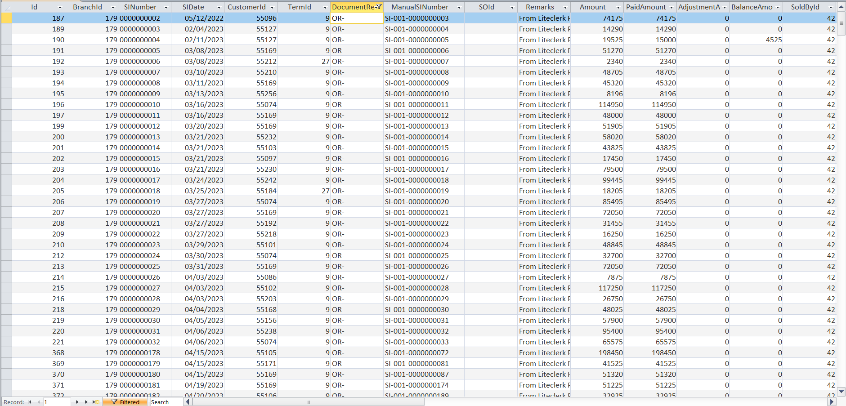
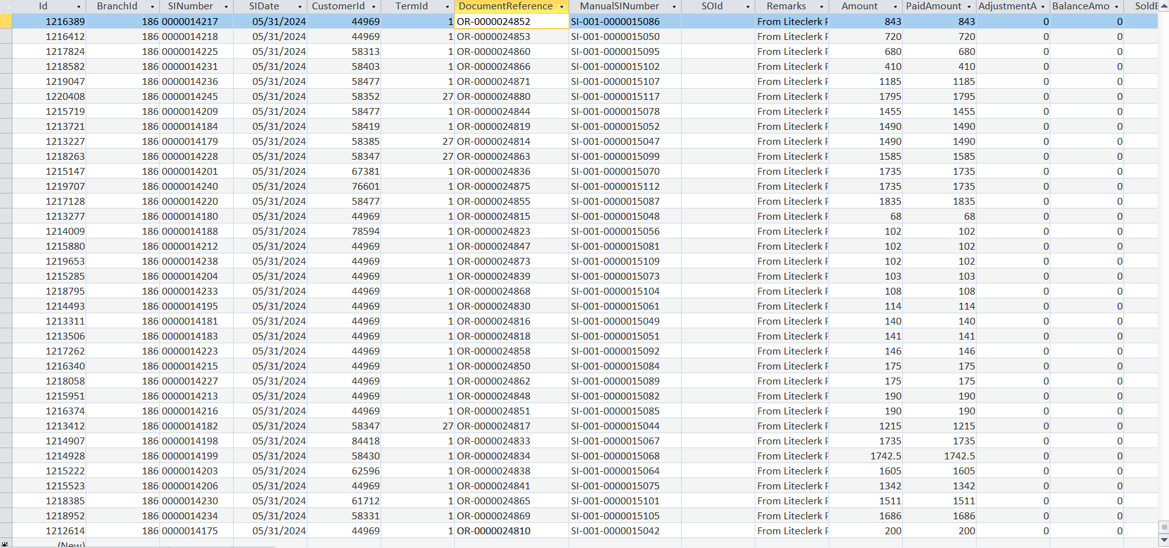
This is a query for AR transactions that are encoded in POS. The DocumentReference that has a value only "OR-".

While in is this query, this is not an AR transaction but a tendered/cash transactions from POS. The DocumentReference has a number after "OR-"
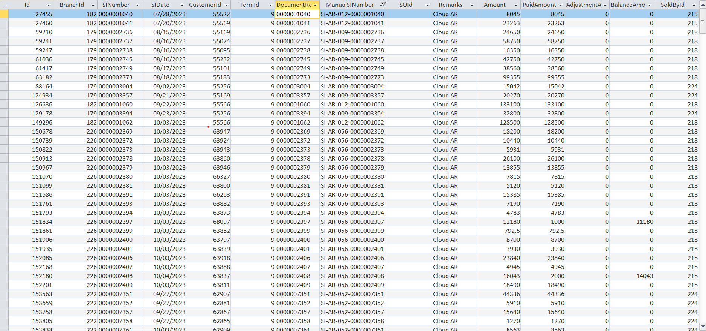
This is a query for AR transactions that are encoded in cloud. SINumber and the DocumentReference is the same but the ManualSINumber's prefix has "SI-AR-".

